**Report z cvičenia č. 5**

**Rastislav Kupčík, Pavol Trník**

Úloha č.1

* Otestovanie možností hardvérového frontu smerovačov

Pred:

tx_limited = 0 (128), errata19 count1 - 0, count2 – 0

* Zmena bandwidth sa vo výpise nijako neprejaví

Zmena parametra tx-ring-limit na hodnotu 4:

tx_limited = 0 (4), errata19 count1 - 0, count2 – 0

Úloha č.2

* Experimenty s FIFO, WFQ a PQ
* Pri každom pokuse sme pomocou D-ITG generovali dva toky s rovnakou intenzitou
* Jeden pokus bol vykonaný tak, aby celkový tok nepresiahol kapacitu linky (10 p/s)
* Druhý tak, aby ju presiahol (20 p/s)
* Kapacita linky bola 128 Kbps
* Prepočty:
  + 1. tok: 8 * 512 * 10 = 40 960 b
    - Súčet tokov je 81 920 b (pohodlne sa zmestí do kapacity linky)
  + 2. tok: 8 * 512 * 20 = 81 920 b
    - Súčet tokov je 163 840b (výrazne prekročí kapacitu)

*FIFO (pod):*

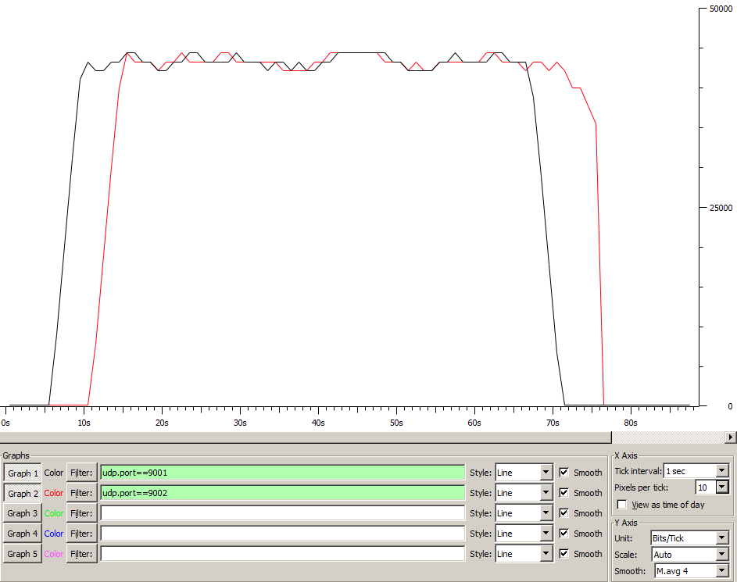

ITGDec version 2.8.1 (r1023)

Compile-time options:

----------------------------------------------------------

Flow number: 1

From 10.0.1.10:59509

To 10.0.2.10:9001

----------------------------------------------------------

Total time = 61.376000 s

Total packets = 600

Minimum delay = -11.945000 s

Maximum delay = -10.446000 s

Average delay = -11.189893 s

Average jitter = 0.004407 s

Delay standard deviation = 0.416689 s

Bytes received = 307200

Average bitrate = 40.041710 Kbit/s

Average packet rate = 9.775808 pkt/s

Packets dropped = 0 (0.00 %)

Average loss-burst size = 0.000000 pkt

----------------------------------------------------------

----------------------------------------------------------

Flow number: 2

From 10.0.1.10:59510

To 10.0.2.10:9002

----------------------------------------------------------

Total time = 61.442000 s

Total packets = 600

Minimum delay = -11.975000 s

Maximum delay = -10.431000 s

Average delay = -11.250022 s

Average jitter = 0.004533 s

Delay standard deviation = 0.419719 s

Bytes received = 307200

Average bitrate = 39.998698 Kbit/s

Average packet rate = 9.765307 pkt/s

Packets dropped = 0 (0.00 %)

Average loss-burst size = 0.000000 pkt

----------------------------------------------------------

__________________________________________________________

**************** TOTAL RESULTS ******************

__________________________________________________________

Number of flows = 2

Total time = 66.507000 s

Total packets = 1200

Minimum delay = -11.975000 s

Maximum delay = -10.431000 s

Average delay = -11.219957 s

Average jitter = 0.006877 s

Delay standard deviation = 0.419286 s

Bytes received = 614400

Average bitrate = 73.905002 Kbit/s

Average packet rate = 18.043213 pkt/s

Packets dropped = 0 (0.00 %)

Average loss-burst size = 0 pkt

Error lines = 0

*FIFO (nad):*

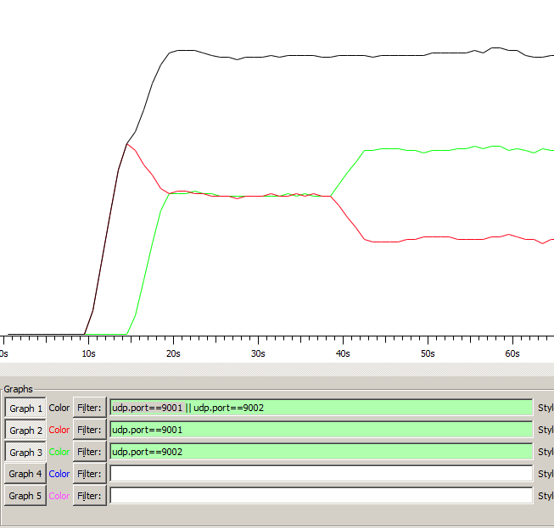

ITGDec version 2.8.1 (r1023)

Compile-time options:

----------------------------------------------------------

Flow number: 1

From 10.0.1.10:59515

To 10.0.2.10:9001

----------------------------------------------------------

Total time = 67.053000 s

Total packets = 828

Minimum delay = -11.482000 s

Maximum delay = -4.316000 s

Average delay = -6.991690 s

Average jitter = 0.010845 s

Delay standard deviation = 2.669124 s

Bytes received = 423936

Average bitrate = 50.579213 Kbit/s

Average packet rate = 12.348441 pkt/s

Packets dropped = 371 (30.94 %)

Average loss-burst size = 1.087977 pkt

----------------------------------------------------------

----------------------------------------------------------

Flow number: 2

From 10.0.1.10:59516

To 10.0.2.10:9002

----------------------------------------------------------

Total time = 65.547000 s

Total packets = 1196

Minimum delay = -11.492000 s

Maximum delay = -4.332000 s

Average delay = -5.769691 s

Average jitter = 0.017412 s

Delay standard deviation = 1.938128 s

Bytes received = 612352

Average bitrate = 74.737456 Kbit/s

Average packet rate = 18.246449 pkt/s

Packets dropped = 4 (0.33 %)

Average loss-burst size = 1.000000 pkt

----------------------------------------------------------

__________________________________________________________

**************** TOTAL RESULTS ******************

__________________________________________________________

Number of flows = 2

Total time = 70.488000 s

Total packets = 2024

Minimum delay = -11.492000 s

Maximum delay = -4.316000 s

Average delay = -6.269599 s

Average jitter = 0.017936 s

Delay standard deviation = 2.344161 s

Bytes received = 1036288

Average bitrate = 117.612984 Kbit/s

Average packet rate = 28.714107 pkt/s

Packets dropped = 375 (15.63 %)

Average loss-burst size = 1.086957 pkt

Error lines = 0

----------------------------------------------------------

*PQ (pod):*

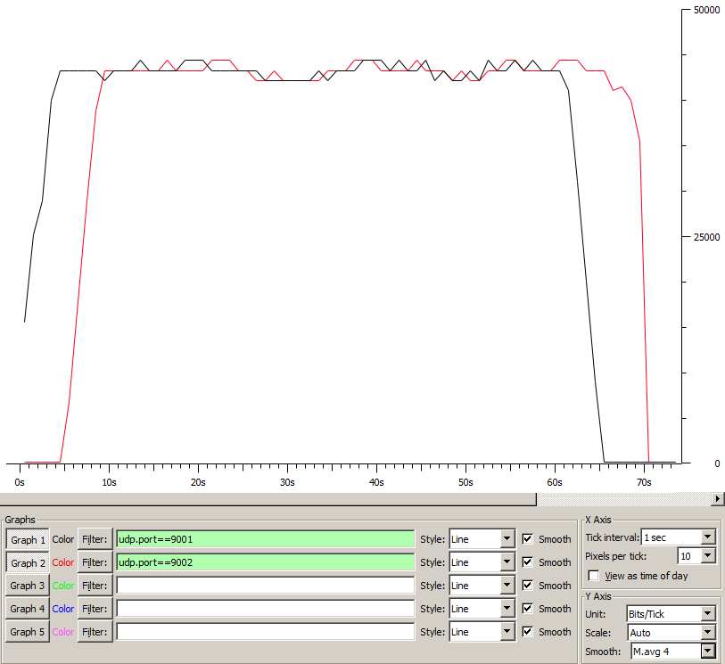

ITGDec version 2.8.1 (r1023)

Compile-time options:

----------------------------------------------------------

Flow number: 1

From 10.0.1.10:56764

To 10.0.2.10:9001

----------------------------------------------------------

Total time = 61.403000 s

Total packets = 600

Minimum delay = -11.642000 s

Maximum delay = -10.127000 s

Average delay = -10.859305 s

Average jitter = 0.004569 s

Delay standard deviation = 0.457477 s

Bytes received = 307200

Average bitrate = 40.024103 Kbit/s

Average packet rate = 9.771510 pkt/s

Packets dropped = 0 (0.00 %)

Average loss-burst size = 0.000000 pkt

----------------------------------------------------------

----------------------------------------------------------

Flow number: 2

From 10.0.1.10:56765

To 10.0.2.10:9002

----------------------------------------------------------

Total time = 61.416000 s

Total packets = 600

Minimum delay = -11.619000 s

Maximum delay = -10.103000 s

Average delay = -10.822627 s

Average jitter = 0.004958 s

Delay standard deviation = 0.448078 s

Bytes received = 307200

Average bitrate = 40.015631 Kbit/s

Average packet rate = 9.769441 pkt/s

Packets dropped = 0 (0.00 %)

Average loss-burst size = 0.000000 pkt

----------------------------------------------------------

__________________________________________________________

**************** TOTAL RESULTS ******************

__________________________________________________________

Number of flows = 2

Total time = 66.451000 s

Total packets = 1200

Minimum delay = -11.642000 s

Maximum delay = -10.103000 s

Average delay = -10.840966 s

Average jitter = 0.006023 s

Delay standard deviation = 0.453173 s

Bytes received = 614400

Average bitrate = 73.967284 Kbit/s

Average packet rate = 18.058419 pkt/s

Packets dropped = 0 (0.00 %)

Average loss-burst size = 0 pkt

Error lines = 0

----------------------------------------------------------

*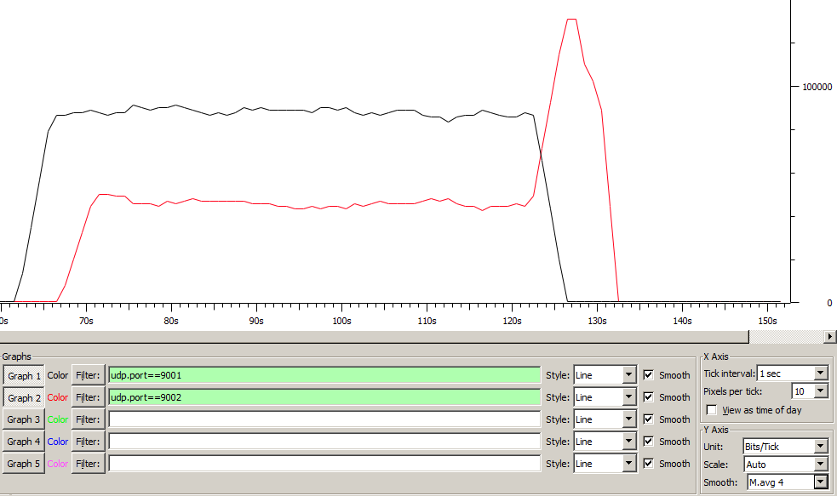PQ (nad)*:

ITGDec version 2.8.1 (r1023)

Compile-time options:

----------------------------------------------------------

Flow number: 1

From 10.0.1.10:60781

To 10.0.2.10:9001

----------------------------------------------------------

Total time = 60.440000 s

Total packets = 1199

Minimum delay = -11.609000 s

Maximum delay = -11.065000 s

Average delay = -11.420801 s

Average jitter = 0.015302 s

Delay standard deviation = 0.127468 s

Bytes received = 613888

Average bitrate = 81.255857 Kbit/s

Average packet rate = 19.837856 pkt/s

Packets dropped = 1 (0.08 %)

Average loss-burst size = 1.000000 pkt

----------------------------------------------------------

----------------------------------------------------------

Flow number: 2

From 10.0.1.10:60782

To 10.0.2.10:9002

----------------------------------------------------------

Total time = 60.925000 s

Total packets = 735

Minimum delay = -11.627000 s

Maximum delay = -4.832000 s

Average delay = -6.701472 s

Average jitter = 0.025743 s

Delay standard deviation = 2.029167 s

Bytes received = 376320

Average bitrate = 49.414198 Kbit/s

Average packet rate = 12.064013 pkt/s

Packets dropped = 465 (38.75 %)

Average loss-burst size = 1.071429 pkt

----------------------------------------------------------

__________________________________________________________

**************** TOTAL RESULTS ******************

__________________________________________________________

Number of flows = 2

Total time = 65.915000 s

Total packets = 1934

Minimum delay = -11.627000 s

Maximum delay = -4.832000 s

Average delay = -9.627261 s

Average jitter = 0.076446 s

Delay standard deviation = 2.611976 s

Bytes received = 990208

Average bitrate = 120.179989 Kbit/s

Average packet rate = 29.340818 pkt/s

Packets dropped = 466 (19.42 %)

Average loss-burst size = 1.071264 pkt

Error lines = 0

----------------------------------------------------------

*WFQ (pod):*

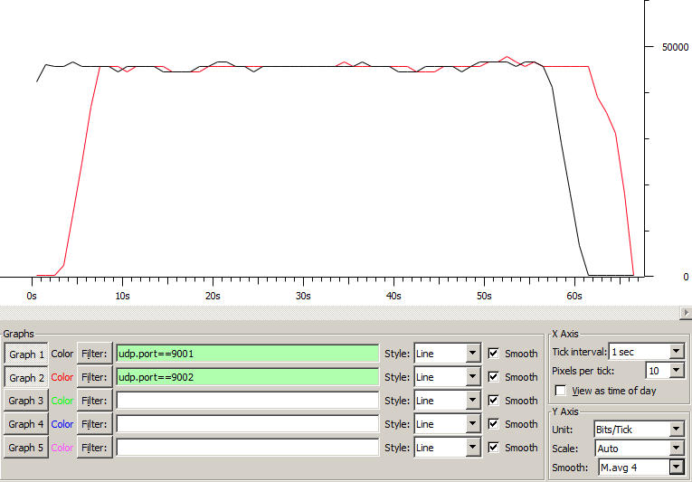

ITGDec version 2.8.1 (r1023)

Compile-time options:

----------------------------------------------------------

Flow number: 1

From 10.0.1.10:60844

To 10.0.2.10:9001

----------------------------------------------------------

Total time = 58.452000 s

Total packets = 600

Minimum delay = -12.532000 s

Maximum delay = -11.083000 s

Average delay = -11.747230 s

Average jitter = 0.004780 s

Delay standard deviation = 0.398957 s

Bytes received = 307200

Average bitrate = 42.044755 Kbit/s

Average packet rate = 10.264833 pkt/s

Packets dropped = 0 (0.00 %)

Average loss-burst size = 0.000000 pkt

----------------------------------------------------------

----------------------------------------------------------

Flow number: 2

From 10.0.1.10:60845

To 10.0.2.10:9002

----------------------------------------------------------

Total time = 58.432000 s

Total packets = 600

Minimum delay = -12.737000 s

Maximum delay = -11.269000 s

Average delay = -11.939637 s

Average jitter = 0.004698 s

Delay standard deviation = 0.416702 s

Bytes received = 307200

Average bitrate = 42.059146 Kbit/s

Average packet rate = 10.268346 pkt/s

Packets dropped = 0 (0.00 %)

Average loss-burst size = 0.000000 pkt

----------------------------------------------------------

__________________________________________________________

**************** TOTAL RESULTS ******************

__________________________________________________________

Number of flows = 2

Total time = 63.248000 s

Total packets = 1200

Minimum delay = -12.737000 s

Maximum delay = -11.083000 s

Average delay = -11.843433 s

Average jitter = 0.007146 s

Delay standard deviation = 0.419117 s

Bytes received = 614400

Average bitrate = 77.713129 Kbit/s

Average packet rate = 18.972932 pkt/s

Packets dropped = 0 (0.00 %)

Average loss-burst size = 0 pkt

Error lines = 0

*WFQ (nad):*

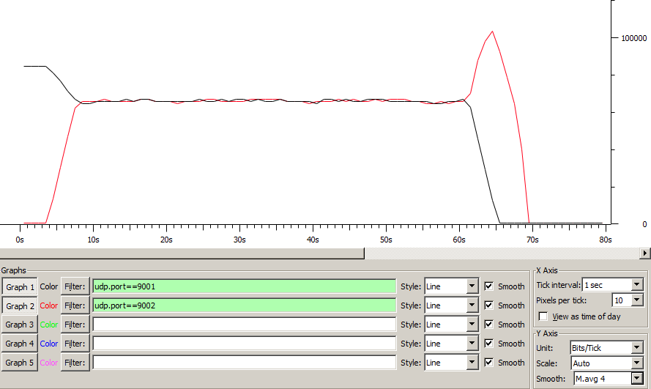

ITGDec version 2.8.1 (r1023)

Compile-time options:

----------------------------------------------------------

Flow number: 1

From 10.0.1.10:60839

To 10.0.2.10:9001

----------------------------------------------------------

Total time = 61.507000 s

Total packets = 934

Minimum delay = -11.202000 s

Maximum delay = -8.586000 s

Average delay = -9.463946 s

Average jitter = 0.019970 s

Delay standard deviation = 0.714440 s

Bytes received = 478208

Average bitrate = 62.198839 Kbit/s

Average packet rate = 15.185263 pkt/s

Packets dropped = 245 (20.78 %)

Average loss-burst size = 1.000000 pkt

----------------------------------------------------------

----------------------------------------------------------

Flow number: 2

From 10.0.1.10:60840

To 10.0.2.10:9002

----------------------------------------------------------

Total time = 61.298000 s

Total packets = 943

Minimum delay = -11.164000 s

Maximum delay = -8.693000 s

Average delay = -9.413765 s

Average jitter = 0.021370 s

Delay standard deviation = 0.454255 s

Bytes received = 482816

Average bitrate = 63.012301 Kbit/s

Average packet rate = 15.383862 pkt/s

Packets dropped = 257 (21.42 %)

Average loss-burst size = 1.003906 pkt

----------------------------------------------------------

__________________________________________________________

**************** TOTAL RESULTS ******************

__________________________________________________________

Number of flows = 2

Total time = 66.364000 s

Total packets = 1877

Minimum delay = -11.202000 s

Maximum delay = -8.586000 s

Average delay = -9.438735 s

Average jitter = 0.022850 s

Delay standard deviation = 0.598570 s

Bytes received = 961024

Average bitrate = 115.848834 Kbit/s

Average packet rate = 28.283407 pkt/s

Packets dropped = 502 (21.10 %)

Average loss-burst size = 1.001996 pkt

Error lines = 0

----------------------------------------------------------